Smart farmer - IoT Enabled Smart Farming Application

SOLUTION ARCHITECTURE

**TEAM ID:**PNT2022TMID23510

**TEAM MEMBERS:**

Parveen Rehana

Nandhini V

Thanya V

Swetha P

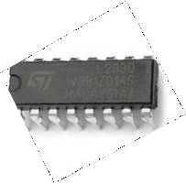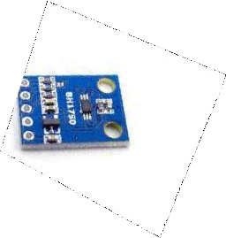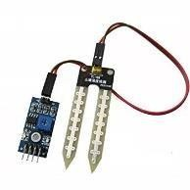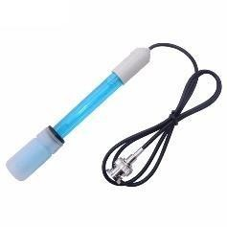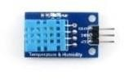



**TEMPERATURE AND HUMIDITY SENSOR**

**L293D (16 PIN IC )**

**SOIL MOISTURE SENSOR**

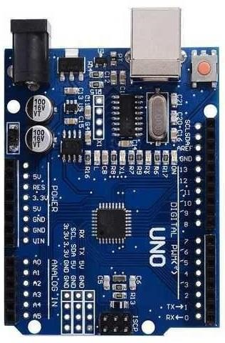

**ARDUINO-UNO**

**IBM IoT CLOUD**

**MOBILE APP**

**LIGHT INTENSITY SENSOR**

**pH SENSOR**

**OPEN WEATHER API**

* The different soil parameters (temperature, humidity, light intensity, pH level) are sensed using different sensors and the obtained value is stored in IBM cloud.
* Arduino uno is used as a processing unit which processes the data obtained from sensors and weather data from weather API.
* Node red is used as a programming tool to wire the hardware, software and APIs. The MQTT protocol is followed for communication.
* All the collected data are provided to the user through a mobile application which was developed using MIT app inventor. The user could make decision through an app, whether to water the crop or not depending upon the sensor values.